#include <stdio.h>

#include <stdlib.h>

main()

{

int grade, sum = 0, pass = 0, fail = 0;

double total;

printf("Enter a test score (-1 to quit):");

scanf_s("%i", &grade);

sum = sum + pass;

sum = sum + fail;

if (grade > 100)

{

printf("That is not a valid grade!\n");

grade = 0;

}

else if (grade >= 70) {

pass = 1;

}

else if (grade < 69) {

pass = 0;

}

while (grade != -1) {

printf("Enter a test score (-1 to quit):");

scanf_s("%i", &grade);

// Adds up the number of loops and grades

sum = sum + 1;

// Invalid grade is not counted to the sum

if (grade > 100)

{

printf("That is not a valid grade!\n");

grade = 0;

sum = sum - 1;

}

// Equal or above 70 is passing

else if (grade >= 70) {

pass = pass + 1;

}

// Below 69 is failing

else if (grade < 69 && grade != -1) {

fail = fail + 1;

}

}

// Overcast allows the int to calculate specific values

// The number of "pass" - passing grades above 70, out of the "sum" - the number of total grades

total = ((double) pass / sum) * 100;

// Number of passing grades out of the total

printf("\n You have entered %i passing grades. \n", pass);

printf("\n'%.2lf' of the valid grades entered are passing grades.\n", total);

}

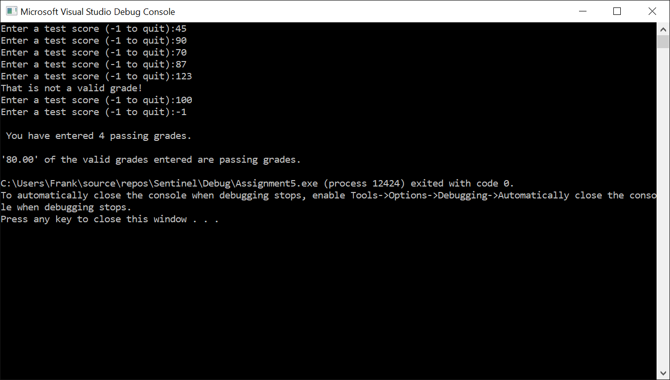

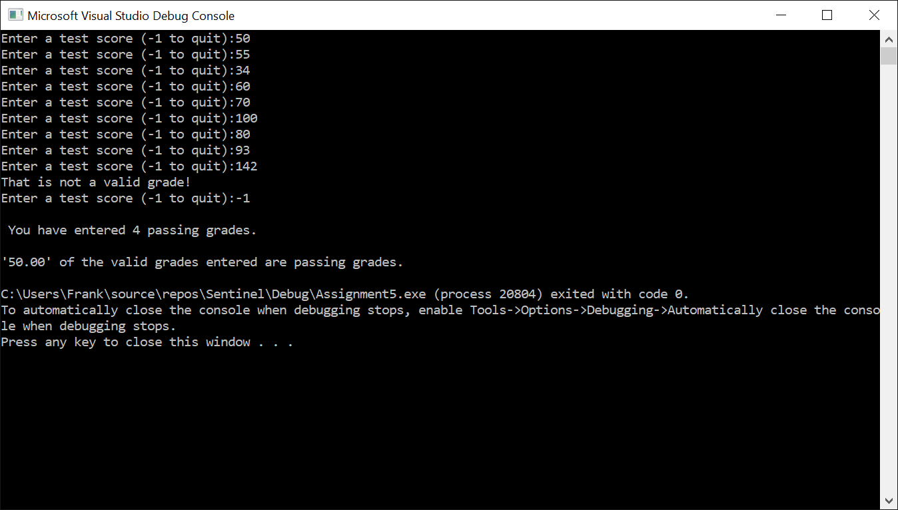

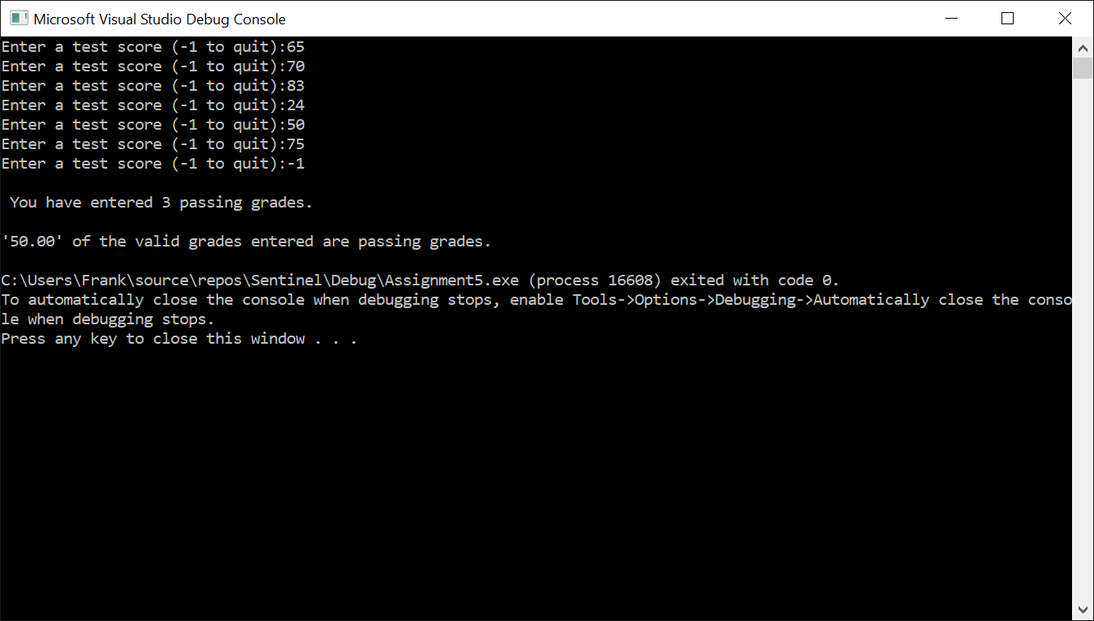

**Assignment 5 – Programming**

We want to count how many passing grades are entered. We don’t know how many grades there will be.

**IPO**

|  |  |  |
| --- | --- | --- |
| **Input**  Grade, sum, pass, fail, total | **Processing**  Enter **grades** from 1-100, identify which are **passing** grades and **failing** grades, calculate the passing grades out of the **total** grades entered. | **Output**  Output passing grades out of total grades entered. |

**Test Case**

|  |  |  |
| --- | --- | --- |
| Input | Pass or Fail | Result |
| Grade 1: 45 | FAIL | FAIL |
| Grade 2: 90 | PASS | PASS |
| Grade 3: 70 | PASS | PASS |
| Grade 4: 123 | INVALID | That is not a valid grade! |
| Grade 5: 100 | PASS | PASS |
| Total : 4/5 | 80% Pass | 80% of the valid grades entered are passing grades. |
|  |  |  |

**Test Case 2**

|  |  |  |
| --- | --- | --- |
| Input | Pass or Fail | Result |
| Grade 1: 50 | FAIL | FAIL |
| Grade 2: 55 | FAIL | FAIL |
| Grade 3: 34 | FAIL | FAIL |
| Grade 4: 60 | FAIL | FAIL |
| Grade 5: 70 | PASS | PASS |
| Grade 6: 100 | PASS | PASS |
| Grade 7: 80 | PASS | PASS |
| Grade 8: 93 | PASS | PASS |
| Grade 9: 142 | INVALID | That is not a valid grade! |
| Total 4/8 | 50% PASS | 50% of the valid grades entered are passing grades. |

**Test Case 3**

|  |  |  |
| --- | --- | --- |
| Input | Pass or Fail | Result |
| Grade 1: 65 | FAIL | FAIL |
| Grade 2: 70 | PASS | PASS |
| Grade 3: 83 | PASS | PASS |
| Grade 4: 24 | FAIL | FAIL |
| Grade 5: 50 | FAIL | FAIL |
| Grade 6: 75 | PASS | PASS |
| Total 3/6 | 50% PASS | 50% of the valid grades entered are passing grades. |